* **Write SQL query to solve the problem given below**

Consider three table named as city, customer and country

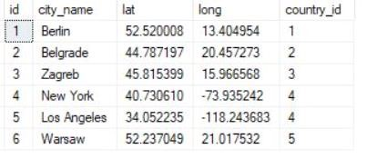 The city table is given below :

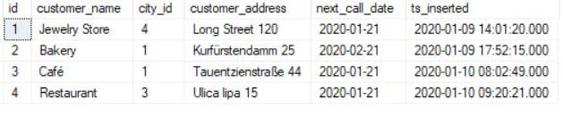 The Customer table :

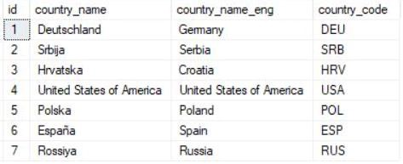 The Country table :

Note :

* While each **city** has a related **country**, not all countries have related cities (Spain & Russia don’t have them)

* Same stands for the customers. Each **customer** has the **city_id** value defined, but only

3 cities are being used (Berlin, Zagreb & New York)

Now commute the following tasks :

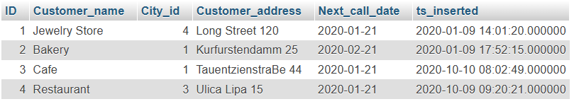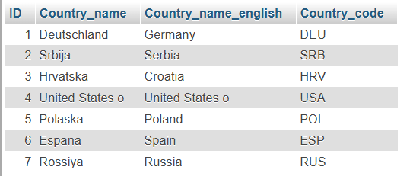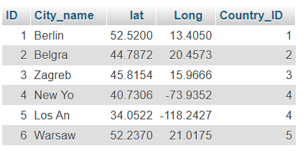

**Task : 1** (join multiple tables using left join)

List all Countries and customers related to these countries.

For each country displaying its name in English, the name of the city customer is located in as well as the name of the customer.

Return even countries without related cities and customers.

**(solution)**

**-- Task_1 Left join**

[SELECT](http://localhost/phpmyadmin/url.php?url=https://dev.mysql.com/doc/refman/8.0/en/select.html) country.ID, country.Country_Name, Country.Country_name_english, country.Country_code, city.City_name, customer.Customer_name FROM country [LEFT](http://localhost/phpmyadmin/url.php?url=https://dev.mysql.com/doc/refman/8.0/en/string-functions.html%23function_left) JOIN city ON country.ID = city.country_ID [LEFT](http://localhost/phpmyadmin/url.php?url=https://dev.mysql.com/doc/refman/8.0/en/string-functions.html%23function_left) JOIN customer ON city.ID = customer.city_id;

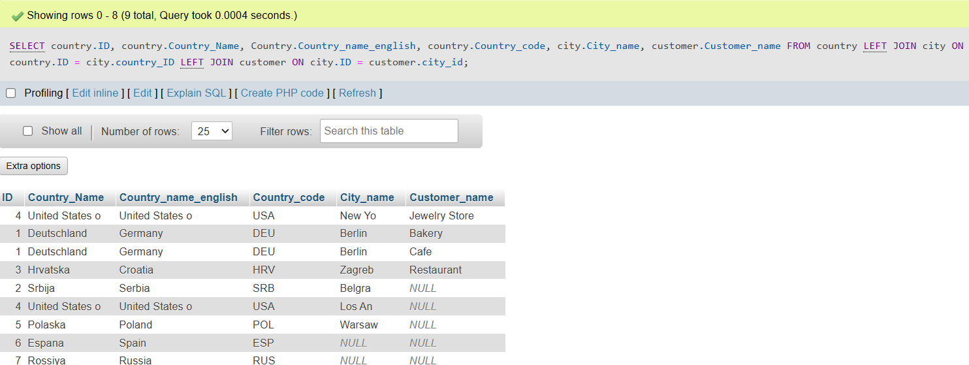

**Task : 2** (join multiple tables using both left and inner join)

Return the list of all countries that have pairs(exclude countries which are not referenced by any city). For such pairs return all customers.

Return even pairs of not having a single customer

Make sure to make your code clean neat

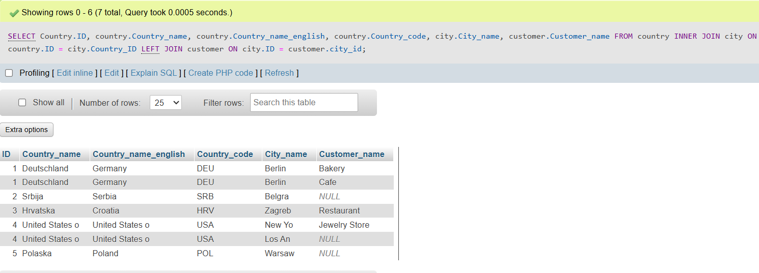[SELECT](http://localhost/phpmyadmin/url.php?url=https://dev.mysql.com/doc/refman/8.0/en/select.html) Country.ID, country.Country_name, country.Country_name_english, country.Country_code, city.City_name, customer.Customer_name FROM country INNER JOIN city ON country.ID = city.Country_ID [LEFT](http://localhost/phpmyadmin/url.php?url=https://dev.mysql.com/doc/refman/8.0/en/string-functions.html%23function_left) JOIN customer ON city.ID = customer.city_id;